Yêu cầu lần 1

# Dùng Github để lưu trữ tài liệu

* Tạo folder

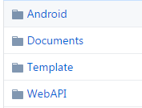

* Viết SRS cho đề tài và đưa vào thư mục Documents.
* Gửi mail đường link github vào địa chỉ [truongbathai@tdc.edu.vn](mailto:truongbathai@tdc.edu.vn) trước ngày 24/04/2017.

Tham khảo:

<https://daynhauhoc.com/t/huong-dan-dung-github-tren-windows-co-ban-step-by-step/6526>

Work Management System

Software Requirement Specification

Version 1.0

**Revision History**

|  |  |  |  |  |
| --- | --- | --- | --- | --- |
| **Revised by** | **Author** | **Description** | **Version** | **Date** |
|  |  | First version | 1.0 | 23/11/2016 |
|  |  |  |  |  |
|  |  |  |  |  |
|  |  |  |  |  |
|  |  |  |  |  |

**Table of Contents**

**1.** **Introduction**

**1.1** **Overview**

**1.2** **Scope**

**2.** **Functional Requirements**

**2.1** **Feature/Component #1: Loading Data Screen**

2.1.1 Users Interfaces

2.1.2 Functional Requirements

**2.2** **Feature/Component #2: Connection Error Screen**

2.2.1 Users Interfaces

2.2.1 Functional Requirements

**2.3** **Feature/Component #3: Not Found Screen**

2.3.1 User Interfaces

2.3.2 Functional Requirements

**2.4** **Feature/Component #4: Work List Screen**

2.4.1 User Interfaces

2.4.2 Functional Requirements

**2.5** **Feature/Component #5: Detail Screen**

2.5.1 User Interfaces

2.5.2 Functional Requirements

# **Introduction**

## **Overview**

This is the application that allows the leader to members assigned based on the phone number. Easy job assignment, arrange to work smart and timely reminders.

## **Scope**

* Demo version
* Demo version is for display purpose only, link to Database, not link to affiliated sites
* Android OS: Android: OS 4.0.X to 4.1.X
* Android test devices: Sony Xperia Z, Asus Zenfone 5, Samsung Galaxy A3
* Android screen resolutions: 4 inch, 5 inch, 5.5 inch
* Support screen orientation in landscape mode only

# **Functional Requirements**

## **Feature/Component #1: Enter Phone Number**

### Users Interfaces

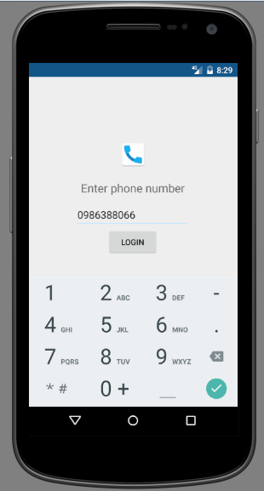

### Functional Requirements

|  |  |  |  |
| --- | --- | --- | --- |
| **Response** | **Action** | **Description** | **Item** |
| N/A | N/A | User must enter phone number. | **Phone Number editText** |
| Received sms verify code. | Send phone number to server. | Waiting to response from server. | **LogIn button** |
| N/A | N/A | User use to enter phone number to Phone Number editText. | **Keyboard** |

## **Feature/Component #2: Loading Data Screen**

### Users Interfaces

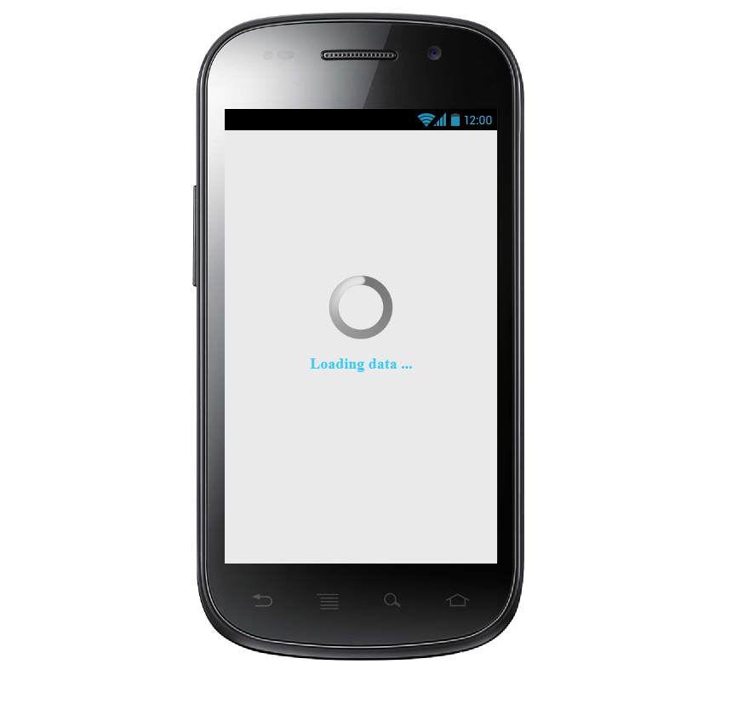*Image1: Loading data from server*

### Functional Requirements

|  |  |  |  |
| --- | --- | --- | --- |
| **Response** | **Action** | **Description** | **Item** |
| N/A | N/A | Loading Screen has 1 Spinner, 1 textview:   * Spinner loading data * Textview “Loading data” | **Loading Screen** |
| Load data to Work List Screen | Load data from the server | Waiting to load data from the server | **Loading data** |

## **Feature/Component #3: Connection Error Screen**

### 2.2.1 Users Interfaces

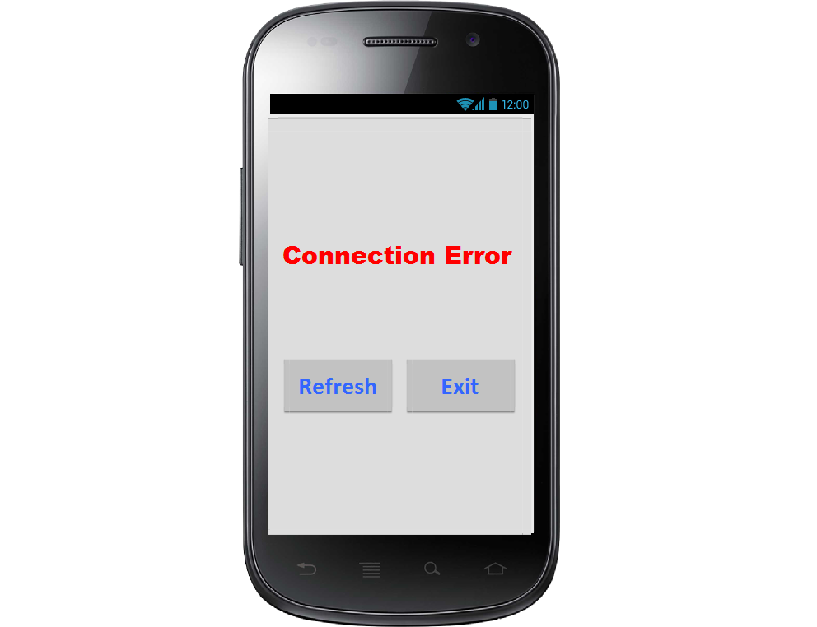

*Image1: Connection error*

### Functional Requirements

|  |  |  |  |
| --- | --- | --- | --- |
| **Response** | **Action** | **Description** | **Item** |
| N/A | N/A | Loading Screen has 1 Textview, 2 button:   * Textview “Connection Error” * Button “Refresh” * Button “Exit” | **Connection error screen** |
| Display loading data screen | Load data from server | Reload data from server | **Refresh button** |
| Close application | Close application | Close application | **Exit button** |

## **Feature/Component #4: Not Found Screen**

### User Interfaces

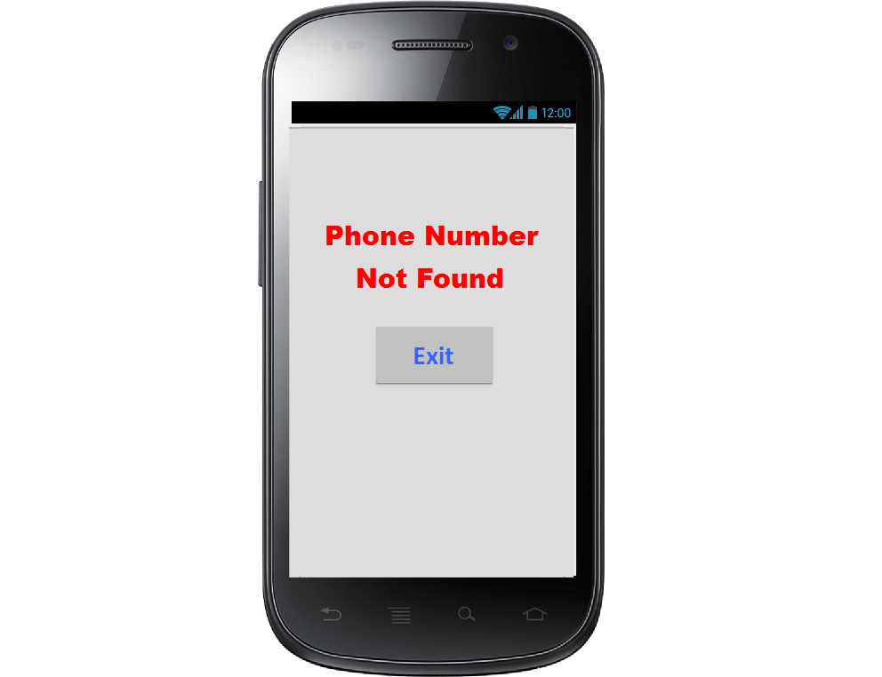

*Image1: Not found phone number*

### Functional Requirements

|  |  |  |  |
| --- | --- | --- | --- |
| **Response** | **Action** | **Description** | **Item** |
| N/A | N/A | Loading Screen has 1 Textview, 1 button:   * Textview “Phone Number Not Found” * Button “Exit” | **Not found screen** |
| Close application | Close application | Close application | **Exit button** |

## **Feature/Component #5: Work List Screen**

### User Interfaces

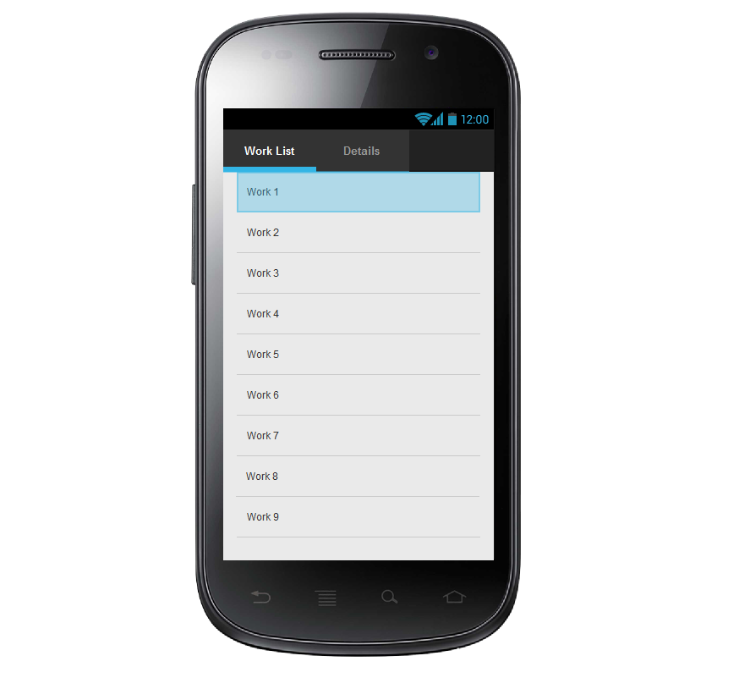

*Image2: Work List*

### Functional Requirements

|  |  |  |  |
| --- | --- | --- | --- |
| **Response** | **Action** | **Description** | **Item** |
| N/A | N/A | Work List Screen has 2 Tabs, 1 Listview to display the list of work:   * Work List * Detail * stview work | **Work List Screen** |
| Work list is showed | Tap on Work List | Show the work list loading from the server | **Work List Tab** |
| Disable | Disable | Tab disabled when not at work | **Detail Tab** |

## **Feature/Component #6: Detail Screen**

### User Interfaces

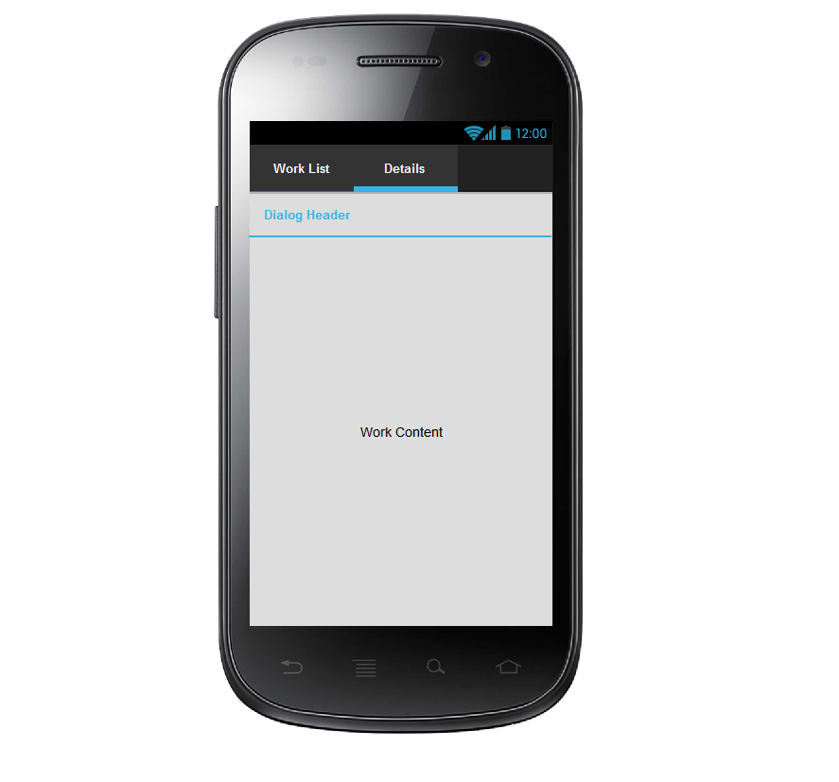

*Image3: Details*

### Functional Requirements

|  |  |  |  |
| --- | --- | --- | --- |
| **Response** | **Action** | **Description** | **Item** |
| N/A | N/A | Detail Screen has 2 Tabs and 1 textbox title and 1 text content work   * Tab Work list * Tab detail * Textbox title work * Text content work | **Detail on Screen** |
| Work detail is showed | Tap on detail | Show detail work when press on tab Detail include:   * Title * Description work | **Tab detail** |
| Title is showed |  | Shows Title of work | **Title** |
| List items are displayed |  | Description detail work | **Work content** |